**Week 2 Project: Docker Containers**

**Step 1: Download MongoDB Image for Docker**

1. Your Docker service needs to be active and running. You can quickly check the current status by entering the following command in your terminal:

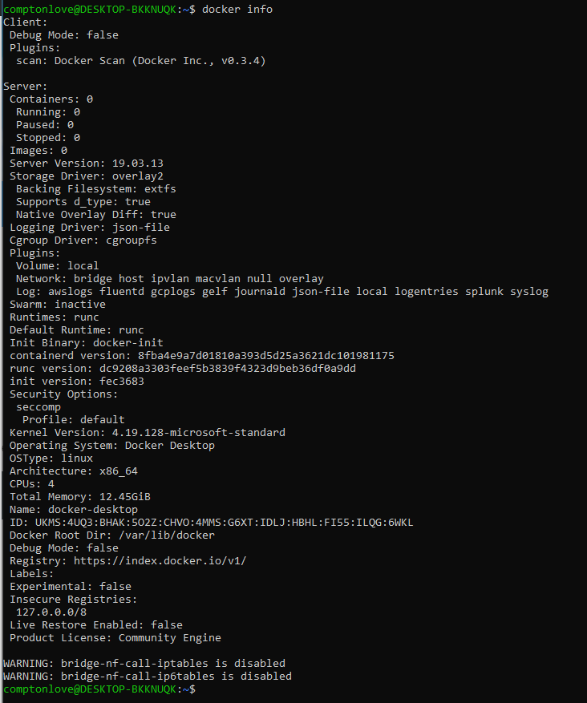

1. Proceed to download the latest official Docker image for the MongoDB database:

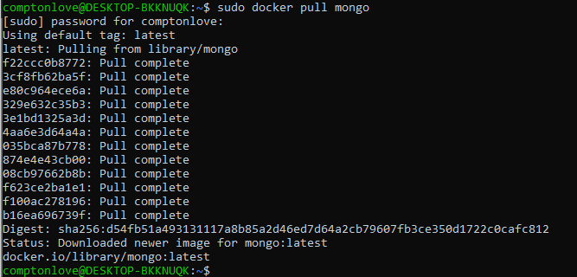

1. List the images in your Docker repository with the following command:

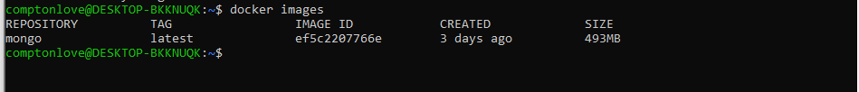

**Step 2: Deploy MongoDB Container**

1. a- Create a **/mongodata**directory on the host system:



1. Start the Docker container with the **run** command using the mongo image. The **/data/db** directory in the container is mounted as **/mongodata** on the host. Additionally, this command changes the name of the container to mongodb:



1. Once the MongoDB server starts running in a container, check the status by typing:

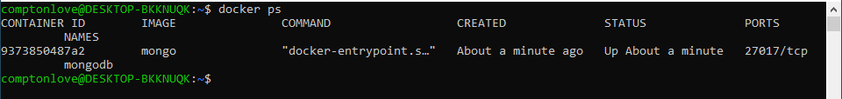

1. Optionally you can specify the MongoDB port explicitly:  
   The default port number is **27017,**as can be seen in the output**.**

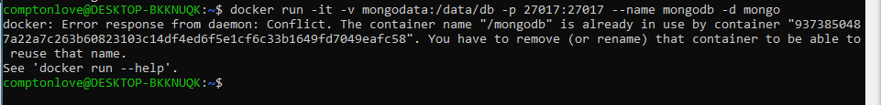

Error due to using the first run option on number 2.

1. Always check the Docker log to see the chain of events after making changes:

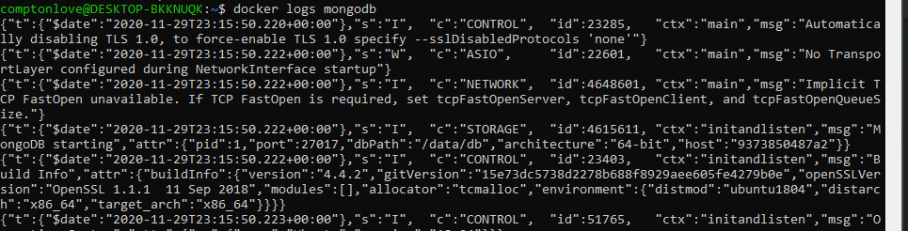

**Step 3: Start Interactive Docker Terminal (Shell) to Manage MongoDB Database**

1.The container is currently running in **a detached mode**. Connect to the container using the interactive terminal instead:

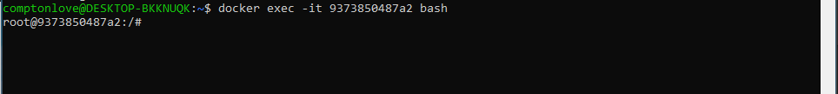

**3.Start the MongoDB shell by typing mongo in the interactive terminal.**

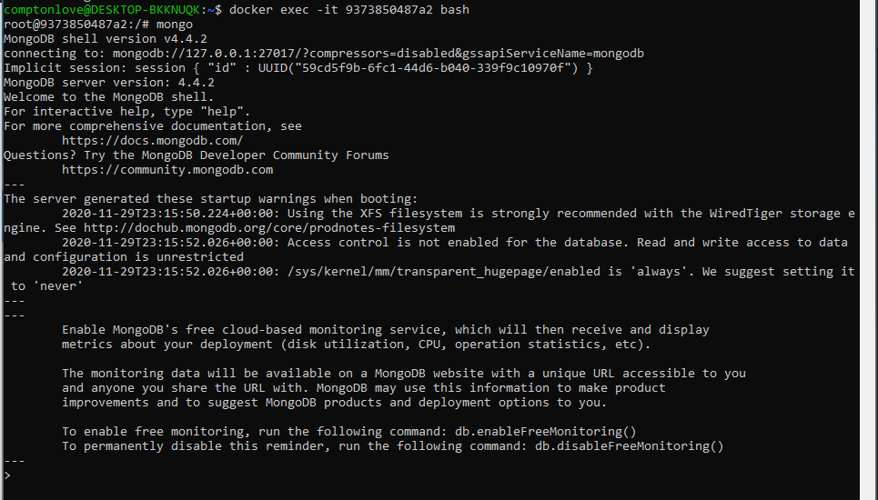

Shows Default Databases:

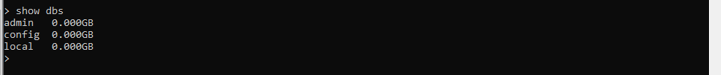

Create a new Database:



Insert a new record into the database:

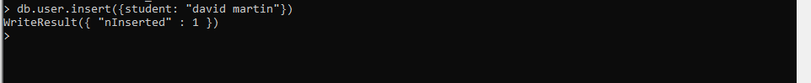

Find the record in the database:

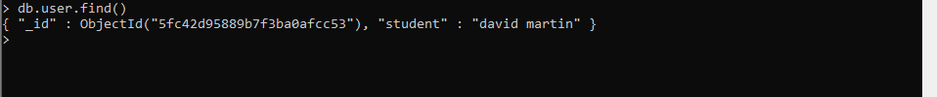

Show the list of Database:

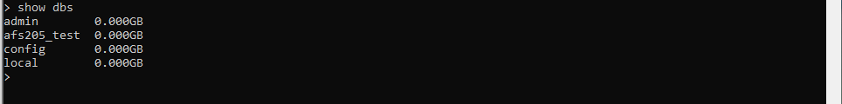

How to Exit MongoDB and Interactive Shell:

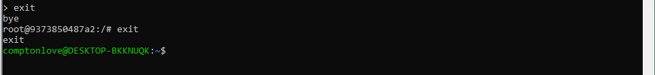

**Stopping and Restarting MongoDB Database**

1. The **docker stop** command is a short and clear command that [stops running container instances (Links to an external site.)](https://phoenixnap.com/kb/how-to-list-start-stop-docker-containers):



2. Inspect the list of running Docker containers by typing:



3.Containers are started by using the **docker start** command:



4.The list of running containers now confirms that the MongoDB database has been initiated once again:

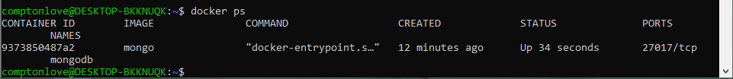

END